**Social Media Marketing**

**Week 3: Social Media Advertising**

**Essentials.**

**Submitted By: Iqra Tariq**

**Objective: Understand basics of social media ads, audience targeting and ad content.**

**Task 1:** Research **types of ads (image, video, carousel, story ads) on** Facebook & Instagram.

**Image ad:**

An **image ad** for university admission is a visually appealing advertisement that uses a **single high-quality image** to promote the university and encourage prospective students to apply.

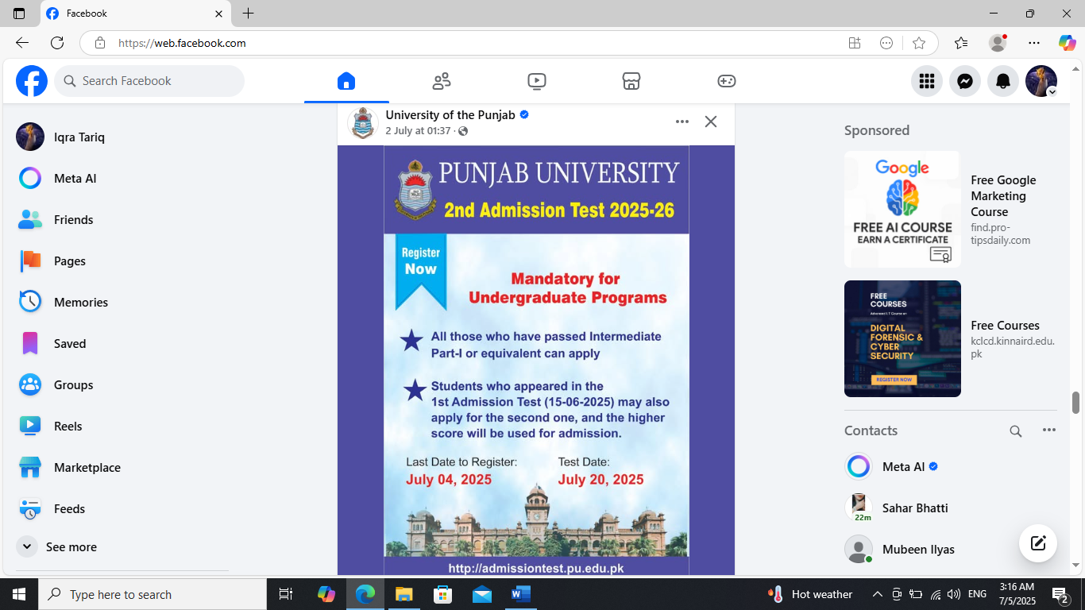

**Video ad:**

A **video ad** designed to promote a **peaceful mind** uses **calming visuals, soothing music, and gentle narration** to evoke a sense of relaxation and mental clarity.

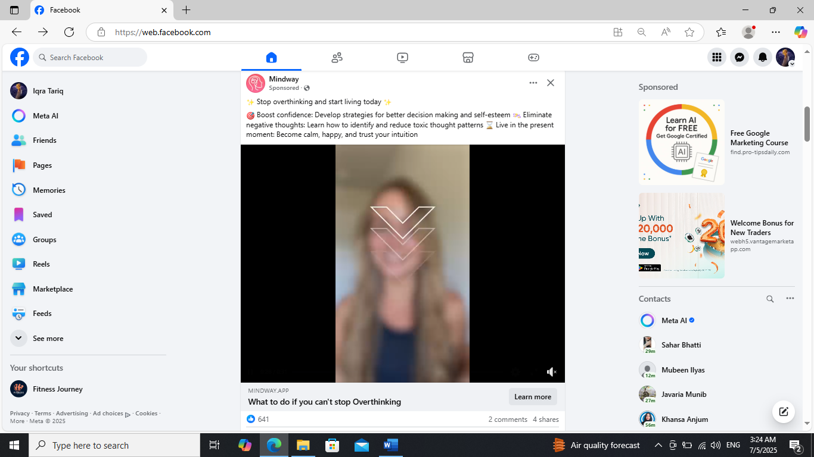

**Carousel ad:**

A **carousel ad** for **Sapphire clothing** showcases multiple clothing items or looks in a single swipe able ad, allowing users to browse different styles directly within Facebook or Instagram.

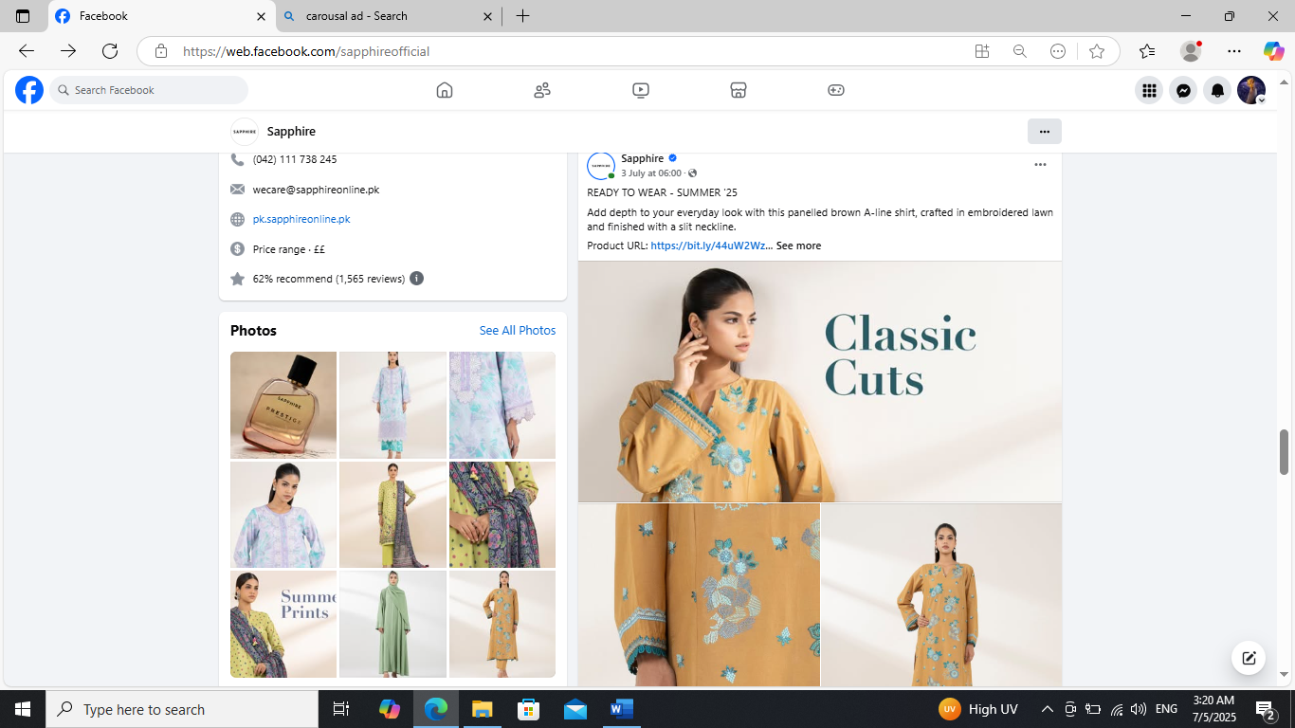

**Story ad:**

A **story ad** for **mind coaching** is a full-screen, vertical ad that appears between user stories on Instagram or Facebook. It delivers a **quick, impactful message** to promote personal growth, stress relief, or mindset transformation.

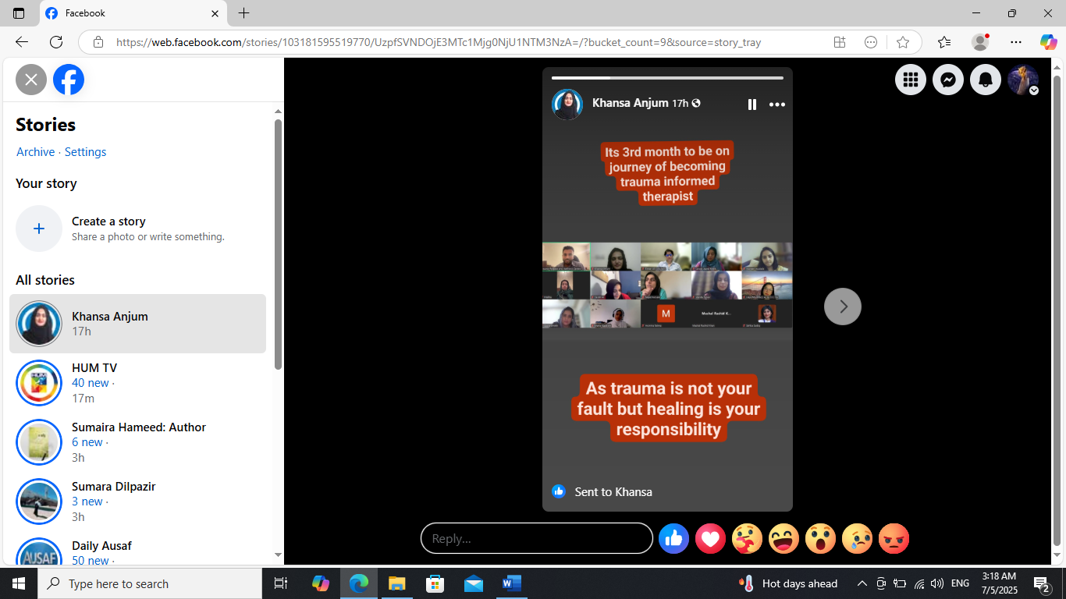

**Task 2:** Design a **sample image ad and video ad post** for a mock product.

**Image ad post:**

**Core Flex Pro**

Sick of crowded gyms and bulky equipment? Meet **Core Flex Pro** — the smart resistance band system that fits in your bag but trains like a full gym.

* Real-time tracking via our Bluetooth-connected app
* Personalized workouts that adapt to your goals
* Compact. Portable. Built for results.

Whether you're at home, in the park, or on the go — **Core Flex Pro** gives you the power to crush your workouts, wherever life takes you.

Resistance that pushes back. Progress you can see

Ready to take control of your fitness?

**Download the Core Flex App & train smarter today**  
**coreflexpro.fit**

#CoreFlexPro #SmartFitness #PortableGym #TrainAnywhere #FitnessInnovation #HomeWorkout #FitTech



**Video ad post:**

**Core Flex Pro**  
**No Gym? No Problem.**  
Transform any space into your personal training zone with **Core Flex Pro** — the smart resistance system that fits in your bag but trains like a full gym.

Personalized workouts  
Real-time tracking  
Total body strength — anytime, anywhere

**Train smarter. Move stronger. Stay consistent.**  
Download the app now: **coreflexpro.fit**

#CoreFlexPro #SmartWorkout #TrainAnywhere #FitnessTech #HomeGym #PortableWorkout #NoExcuses

**[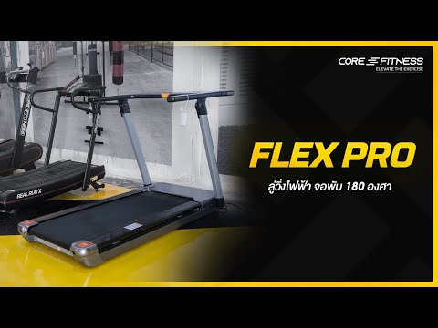](https://www.youtube.com/embed/7KnUmkjwDrU?feature=oembed)**

**Task 3:** Define a **target audience persona (age, gender, interests, location)** for your niche.

**Target audience**– The specific group of people you want to reach with your content, product, or service.

**Persona**– A detailed, human-like description of someone in that target audience. It includes demographics and behavior patterns.

**Niche:** Fitness.

## **Target Audience Persona for Fitness Niche.**

## **Name:** Sarah Ahmad

## **Age:** 25–35 years old

### ****Gender:**** All genders (primarily male and female, with growing non-binary interest)

### ****Location:****

* Urban and suburban areas
* Primarily U.S., Canada, UK, Australia, and metro cities in Pakistan.
* Health-conscious communities and fitness-forward regions (e.g., Los Angeles, London, Toronto, Bangalore)

### ****Interests:****

* Weight training, fat loss, or muscle building
* Home or gym-based workout routines
* Nutrition, meal prepping, and supplements
* Following fitness influencers and workout challenges on Instagram, TikTok, and YouTube
* Buying fitness gear, activewear, and tech (smartwatches, trackers)
* Lifestyle topics like mindset, recovery, sleep, and productivity
* Exploring diets like keto, vegan, or high-protein meal plans

**Behavior & Mindset:**

* Motivated to improve appearance and health
* Consumes quick, actionable content (short videos, tips)
* Looks for easy-to-follow programs, accountability, and community support
* Influenced by social proof (before/after, reviews, transformation stories)
* Open to digital fitness products: apps, eBooks, challenges, online coaching

### ****Goals:****

* Improve physique and fitness performance
* Build confidence and energy levels
* Stay consistent with workouts and healthy habits
* Track progress and optimize diet/exercise plans
* Feel part of a supportive community

### ****Pain Points:****

* Lack of time or consistency
* Confusion about workout structure and diet
* Struggles with motivation and discipline
* Overwhelmed by conflicting fitness advice online
* Doesn’t know where to start or what’s best for their body type

**Task 4:** Draft a **paid ad caption (primary text, headline, CTA)** for Facebook and Instagram.

## **Facebook/Instagram Paid Ad Copy**

## **Primary Text (Caption):**

Tired of starting over every Monday?  
Get fit from home with our 30-Day Bodyweight Challenge — no gym, no equipment, just real results.

20-minute daily workouts  
Beginner-friendly  
Follow along on your phone

Join thousands who’ve already transformed their bodies and boosted their confidence — all without stepping into a gym.

Ready to take control of your fitness journey?

**Headline:**

Start Your 30-Day Home Fitness Challenge Today

### ****Call to Action (CTA):****

**[Sign Up]** or **[Learn More]**

**Task 5:** Study and summarize **how Facebook Ads Manager or LinkedIn Campaign Manager works** (250 words).

In today's digital marketing landscape, choosing the right advertising platform is crucial for reaching your target audience effectively. LinkedIn Ads and Facebook Ads are two of the most popular options, each offering unique benefits and features.

LinkedIn Ads are primarily designed for B2B marketing, offering precise targeting options based on professional demographics such as job title, industry, and company size. Facebook Ads, on the other hand, excel in B2C marketing with a vast reach and advanced targeting capabilities based on user interests, behaviors, and demographics.

LinkedIn Ads makes it an ideal choice for B2B marketers aiming to connect with decision-makers and professionals in specific fields. LinkedIn’s targeting options are particularly advantageous for campaigns focused on lead generation and fostering professional relationships.

Facebook Ads offers a broader range of targeting options, catering to both B2B and B2C markets. Advertisers can target users based on demographics, interests, behaviors, and life events, providing a more comprehensive reach. Facebook’s advanced algorithms also enhance targeting precision through lookalike audiences and retargeting strategies.

The choice between LinkedIn and Facebook ad formats depends largely on your marketing objectives and target audience. LinkedIn excels in professional networking and lead generation, while Facebook provides more diverse and visually engaging options for reaching a broader audience. Tailoring your creatives to the strengths of each platform can significantly enhance your campaign's effectiveness.

LinkedIn generally has a higher cost per click (CPC) compared to Facebook. This is primarily due to its professional user base, which often includes decision-makers and industry leaders. On the other hand, Facebook offers a more cost-effective advertising solution, with lower CPC and broader audience reach. This makes it an attractive option for businesses with limited budgets who still want to achieve significant outreach.